Order Of Service

Singing: Psalm 18—CW page 69

Reading: Psalm 30

Opening Hymn: TLH 648

Reading: II Corinthians 3:1-11

Request Hymn: CW Supplement 763

Reading: Mark 4:35-41

Sermon Hymn: TLH 436

Sermon Text: Luke 15:1-7

The Lost Sheep

Prayer

The Apostles’ Creed, TLH page 12

Holy Communion

The Lord's Prayer

The Blessing

Closing Hymn: TLH 649

************

Bible Study: Lambs: Fog
Sheep: Gideon, Judges 6-8
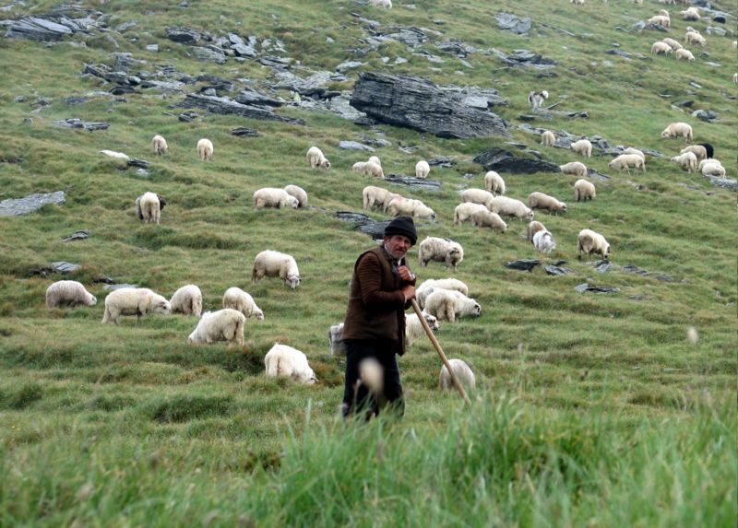

Shepherd With Flock

Water
Of
Life

10 July 2022

W A T E R O F L I F E

Independent Christian Church—Conservative Lutheran Doctrine

Worship Service: 9:30 a.m.

Larry Cooper, Pastor E-Mail address:
111 N. Ridge Road lcooper@wateroflife.cc
Coon Valley, WI 54623 Web Site:
www.wateroflife.cc

* * * * * * * * * * * * * * * * * * * * * * * * * * *

Sermon Text: Luke 15:1-7

The Lost Sheep

* * * * * * * * * * * * * * * * * * * * * * * * * * *

1 Then drew near unto him all the publicans and sinners for to hear him.
2 And the Pharisees and scribes murmured, saying, This man receiveth sinners, and eateth with them.
3 And he spake this parable unto them, saying,
4 What man of you, having an hundred sheep, if he lose one of them, doth not leave the ninety and nine in the wilderness, and go after that which is lost, until he find it?
5 And when he hath found it, he layeth it on his shoulders, rejoicing.
6 And when he cometh home, he calleth together his friends and neighbours, saying unto them, Rejoice with me; for I have found my sheep which was lost.
7 I say unto you, that likewise joy shall be in heaven over one sinner that repenteth, more than over ninety and nine just persons, which need no repentance.

